Chapter 4: Background Information and Joint Fact Finding Road-Map (or could be Appendix X?) [Note: Links are not live but will be added in final report]

A) Grid-Facing
The Grid-Facing Committee asked the Distribution Companies two sets of questions regarding the status of the existing grid-facing infrastructure. The purpose of these questions was to provide an indication as the extent to which the Distribution Companies have adopted grid modernization capabilities and network system enablers (see Figure 3.1).

The first set of questions was intended to get descriptions; installation dates; the levels of deployment of various technologies; and additional characteristics of the various network system enablers. The second set of questions was focused on the Distribution Companies’ current capabilities for integrating distributed generation onto their systems; including information regarding the measurement/estimation of minimum load, equipment to readily integrate distributed generation resources, and additional relevant data. The questions asked, and the Distribution Companies responses to them are available HERE.

The responses to the first set of questions are summarized below in Tables 4-A1, 4-A2, and 4-A3. Table 4-A1 provides an overview of the substations, feeders and capacitors that are currently installed on the utility systems. For each utility, and for each technology type, the table presents the total number, the number of automated technologies, and the percent of the total that is automated. This table also provides some definitions of the different technology categories.

Table 4-A2 provides more details, including the types of network system capabilities (e.g., fault detection, integrated volt/VAR control, remote monitoring) that are located on each utility system. This includes information on the level of the system at which the capabilities are located, including transmission system level, distribution system level, substation level or neither.

Table 4-A3 provides additional details for the network system enablers. This includes when they were installed, status of recent upgrades, and future plans for upgrades.

Based on the responses to the first set of grid facing questions, the Distribution Companies were asked to respond to a second set of grid-facing questions. The first question of this second set asked for the percentage of substations, feeders and line sections where each Distribution Company was able to directly measure minimum load. The second question asked each Distribution Company to provide the number of substation transformers and voltage regulators capable of reverse power flow. Finally, the third question gave each Distribution Company the opportunity to provide any additional data or descriptions that would further explain their deployment of modern grid technologies.

The utilities’ responses to the second set of grid-facing questions are summarized in the tables below. Table 4-A4 shows the percentage of each utility’s system with the ability to measure minimum load. Table 4-A5 shows the percentage of each utility’s systems that are capable of reverse power flow.
Note that the utilities’ responses to these questions include some important notes with more detail on the information in these tables. In addition, the responses include additional information and explanation about the deployment of technologies on the distribution system, beyond what could be summarized here. The complete responses from the utilities can be found HERE.

Table 4-A4. Percentage of Systems With the Ability to Measure Minimum Load
 |  | Substations | Feeders | Line Sections
National Grid |  | 52% | 50% | 27%
NSTAR | North 115/14kV Stations | 100% | 100% | -
NSTAR | North 4kV Stations | 80% | 84% | -
NSTAR | South 115/23kV and 115/13.2kV Stations | 100% | 100%
NSTAR | South 4kV Stations | 5% | 5% | -
NSTAR | North and South 15kv Line Sectionalizing Devices | - | - | 93%
NSTAR | North and South 4kv Line Sectionalizing Devices | - | - | 100%
Unitil |  | 30% | 37% | 0%
WMECO |  | 70% | 36% | 21%

Table 4-A5. Percentage of Systems Capable of Reverse Power Flow
 | Substation Transformers | Substation Regulation | Feeder Regulation
National Grid | Reverse power flow issues regarding DG installation can potentially be addressed on an on-going basis as technologies and operational knowledge matures. | No count available. Percentage is relatively low. New controls have bidirectional capability. | No count available. Percentage is relatively low. New controls have bidirectional capability.
NSTAR | Systems designed for forward power flow. Little experience to date with reverse flow. | Roughly 50%. | Roughly 50%.
Unitil | No substation transformers currently designed for reverse power flow. | No count available. Percentage is relatively low. New controls have bidirectional capability. | No count available. Percentage is relatively low. New controls have bidirectional capability.
WMECO | Systems designed for forward power flow. Little experience to date with reverse flow. | Roughly 50%. | Roughly 50%.

Table 4-A1

 | Substations1 |  |  | Feeders2 |  |  | Capacitors3
 | Total | Automated | Percentage | Total | Automated | Percentage | Total | SCADA Control | Percentage | Automated  Response | Percentage
NSTAR | 200 | 120 | 60% | 1579 | 995 | 63% | 830 | 640 | 77% | 95 | 11%
WMECo | 28 | 10 | 36% | 233 | 134 | 58% | 250 | 62 | 25% | 77 | 31%
National Grid | 258 | 138 | 53% | 1028 | 567 | 55% | 2500 | 0 | 0% | 1800 | 72%
Unitil | 11 | 4 | 36% | 36 | 14 | 39% | 135 | 0 | 0% | 40 | 30%

Category  Definitions | 1 Substation automation is defined as the full SCADA integration (status, control and analog data) of the substation for all major equipment (power transformers, substation capacitors and breakers/reclosers). This may or may not include  the power transformer LTC and/or individual phase regulators for distribution feeders.  In some cases partially automated substations (portion of a substation is fully automated without all distribution feeders being fully automated) have been included in the count (a very small percentage of feeders are in this category). "Full" automation does not typically include feeder phase regulators but does include LTC automation for new installations. | 2 Feeder automation is defined as the full SCADA integration (status, control and analog data) of the feeder breaker/recloser within the substation fence and/or the SCADA control of automatic sectionalizing devices outside the substation fence on the distribution feeder. Additionally non- communication enabled automated loop sectionalizing schemes and/or preferred/alternate schemes have been included as well as more advanced multi-switch/multi-feeder communicating FDIR schemes. These figures include both overhead and underground feeders | 3 Capacitor counts included in this table are line banks only, not substation banks.  SCADA control is defined as the ability to send a signal to remotely operate the bank and may or may not include status of the bank.  Automated response is defined as the presence of a local control capable of operating the bank programmatically based on time, day, date, temperature and/or power quantity values (voltage, current, KW flow, KVAR flow, etc.).

Table 4-A2

NSTAR
System Location Notes
Fault Detection, Isolation, Restoration (FDIR) | Distribution system and substations | 80 auto reconfiguration loops, with 100 additional planned for 2013
Automated Feeder Reconfiguration | Distribution system and substations | FDIR devices continuously monitor system, alerting operators of loading concerns.
Integrated Volt/VAR Control, Conservation Voltage  Reduction | Transmission, distribution, substations | 830 Capacitor bank, of which 640 are controllable remotely. No CVR.
Remote Monitoring & Diagnostics ( equipment conditions) | Transmission, distribution, substations | All major equipment is remotely monitored via SCADA i.e. Substation transformers, remote controlled switches, communications, etc..
Remote Monitoring & Diagnostics (system conditions) | Transmission, distribution, substations | All remote controlled reclosers and ASUs monitor the system providing voltage, current and power factor.

WMECo
System Location Notes
Fault Detection, Isolation, Restoration (FDIR) | Distribution system | 120 recloser loop schemes on its system. All loop schemes operate automatically in response to loss of source voltage.
Automated Feeder Reconfiguration | None
Integrated Volt/VAR Control, Conservation Voltage  Reduction | Distribution system and substations | Manage voltage within a +/- 5% bandwidth, no CVR
Remote Monitoring & Diagnostics ( equipment conditions) | Substation | Alarms alert operators for various abnormal conditions. No capability to remotely sense specific equipment conditions (e.g. oil levels) or diagnose problems.
Remote Monitoring & Diagnostics (system conditions) | Distribution system and substations | DSCADA for remote monitoring and diagnostics of system conditions.

Unitil
System Location Notes
Fault Detection, Isolation, Restoration (FDIR) | Distribution system | One circuit currently has FDIR recloser combination
Automated Feeder Reconfiguration | None
Integrated Volt/VAR Control, Conservation Voltage  Reduction | Distribution system and substations | Manage localized circuit level power factor and voltage through the use of capacitor banks that are automatically controlled based on system condition or time of day.
Remote Monitoring & Diagnostics ( equipment conditions) | None
Remote Monitoring & Diagnostics (system conditions) | Distribution system and substations | SCADA is installed in 4 of 11 substations. This includes remote monitoring on 4 capacitor banks, approximately 45 breakers/reclosers, and 6 transformers.

National Grid
System Location Notes
Fault Detection, Isolation, Restoration (FDIR) | Distribution system | Approximately XX non-communicating or communicating loop sectionalizing schemes and/or preferred/alternative schemes  Small rollout of Advanced Distribution Automation (multi-switch/multi- feeder communicating system) as part of SG pilot
Automated Feeder Reconfiguration | None
Integrated Volt/VAR Control, Conservation Voltage  Reduction | Distribution system | Advanced Local Volt/Var Control: Small rollout as part of SG pilot  2.5/5% voltage reduction on 75% of feeders per NE-ISO operating procedures
Remote Monitoring & Diagnostics ( equipment conditions) | Transmission, distribution, substations | A small subset of large power transformers have remote condition monitoring via SCADA, additionally SCADA alarms alert operators of various abnormal conditions on a wider range of distribution and transmission equipment. A small rollout of devices as part of the SG pilot will provide equipment monitoring on all new devices.
Remote Monitoring & Diagnostics (system conditions) | Transmission, distribution, substations | SCADA for remote monitoring and diagnostics of system conditions within the substation fence. Also remote controlled reclosers monitor the system providing voltage, current and power factor. A small rollout of new equipment as part of the SG pilot will provide near real time monitoring of system conditions at several locations on the pilot feeders.

Table 4-A3

Type When Installed Most Recent Upgrade Future Plans Notes
NSTAR
Distribution Management System (DMS)/SCADA
GE SCADA/EMS: Trans, Sub-trans, North Distribution 1994 2007 Migrate and implement auto-restoration schemes 1,100+ supervisory, and 60,000+ analog & digital points
GE Powerlink Advantage: South Distribution 2005 2011 750+ supervisory, and 40,000 analog & digital points.
Outage Management System (OMS) CGI PragmaLine v2.03 2000 Replaced
GATOR 2003 Planned replacement 2013-2014
Geospatial Information System (GIS) Editor: Custom ESRI North: 1990s, South: 2004 Upgrade in progress
Viewer: ESRI ArcMap with customization 2004 Upgrade in progress
Transmission Editor: ArcFM 2008 Upgrade in progress
GIS-OMS Integration GATOR-GUI 2003 (within OMS upgrade) GIS upgrade in progress OMS Replacement 2013-2014
Billing System
1991 Continuous
Metering System Premierplus4 ? Replaced
FCS (Field Collection System) 2012 Underway
Route Smart ArcGIS 2007 2011
MV90 (Interval Meter Collection) 2006 2009 Upgrade in 2013 for 7000 TOU meters via modem and cellular networks
Meter Data Management System (MDM) Lodestar 2011
OMS-AMR/AMI Integration N/A N/A
Communication Systems Various systems 2008-2010

Type When Installed Upgrades Future Plans Notes
WMECO
Distribution Management System (DMS)/SCADA
Siemens Spectrum Power TG 2002 currently upgrading 2400+ devices, 280,000+ analog & digital points.
Outage Management System (OMS) Oracle Network Management System 2004 2007 upgrade/replacement in 2014
Geospatial Information System (GIS) Editor: GE Smallworld Editor 2002 2008
Viewer: GE SIAS Viewer 2010
Transmission Editor N/A N/A Integration into Smallworld editor around 2013
Viewer: ESRI SilverLight Viewer - custom 2012
GIS-OMS Integration Smallworld 2004 2008 replacement in 2014
Billing System C2 Application 2008 Continuous
Metering System Fieldnet 1990s 2012 Upgrade in 2014
Prime Read (Interval Meter Collection) 2008 Move all to MV90 and retire application
ION Revenue 2005 Move all to MV90 and retire application
Meter Data Management System (MDM) Lodestar MDM 2013
SerViewCom ? 2010 Move all to MV90 and retire application
EVEE Meter Data Warehouse 2003 2012
OMS-AMR/AMI Integration N/A N/A
Communication Systems Fiber 2005-2013
Microwave 2005-2013 Some will be replaced by fiber, where appropriate
Mobile Radio 2005-2008
DSCADA Radios 2012-2013

Type When Installed Upgrades Future Plans Notes
National Grid
Distribution Management System (DMS)/SCADA
None N/A N/A Planned OMS and EMS SCADA interface after OMS installation in fall 2013 to support potential future DMS
Outage Management System (OMS) PowerOn 2006 PowerOn to be replaced with ABB OMS as part of EMS upgrade during fall of 2013
Geospatial Information System (GIS) GE Smallworld 2004 2011 Currently using latest version (V4.2), no upgrade plans for a least three years. T Current GIS is integrated with OMS and WMS
GIS-OMS Integration Fully Integrated - GE Smallworld/PowerOn 2006 PowerOn to be replaced with ABB OMS as part of EMS upgrade during fall of 2013
Billing System Customer Service System (CSS) 2008 Integration of SG Pilot meter data
Metering System
Solid State (22%) around 2000 2012 none planned, but Smart Grid Pilot underway .297 million meters. 92% of all National Grid meters read via Drive-by AMR

B) Time-Varying Rates
Time varying rates (TVR aka dynamic pricing) issues and experience in the U.S. and abroad were presented by the Brattle Group at the Kick-Off Summit (See Brattle Presentation HERE 11/14/12). The Customer-Facing Subcommittee then heard detailed presentations regarding the smart grid pilots from NSTAR, NGRID, and UNITIL at its first meeting (See Utility Presentations Here 1/9/13), and the Steering Committee heard an updated presentation on NSTAR’s pilot at its 6th meeting (See NSTAR/Navigant Presentation HERE 5/22/13). At the second Customer-Facing Subcommittee meeting, the Regulatory Assistance Project presented additional information on experience and issues in the U.S. and abroad on TVR, and the Attorney General’s consultant presented both the principles developed by NASUCA et al on consumer protections related to TVR and AMI as well as additional recent experience across the U.S. on TVR and AMI (See RAP and AG presentations HERE 2/26/13). Finally, at the 5th Steering Committee the Attorney General presented some research it had done on TVR in other restructured states (See Basic Service Memo & AG TVR Table HERE 5/14/13). The following tables and graphs extract some of the summary tables and highlights from these presentations; however, please see the actual presentations and the meeting summaries from the meetings in which the documents were presented and discussed for the full details.

Current rates for basic service residential and small commercial customers of Massachusetts investor-owned Distribution Companies are essentially a flat rate that does not vary by time of day, day of the week, or by season. In this regard, Massachusetts is typical of other retail restructuring states where a default service is provided to residential and small commercial customers pursuant to wholesale market contracts that are intended to reduce price volatility.

Time varying rates are rates that have some variability based on when energy is consumed and generally reflect shorter term wholesale market prices. As Table B1-X illustrates there is a continuum of ways to design rates to make them more or less reflective of the frequency of changes in price at the wholesale level. These range from time-of-use (TOU) rates that divide the day into two or three time periods with different rates that are then fixed for a season or a year, up to real-time pricing (RTP) where prices can change hourly to reflect wholesale pricing conditions. Critical peak pricing (CPP) is generally an overlay on TOU pricing that allows for prices to rise significantly at pre-announced times when costs are projected to rise significantly. Peak time rebates (PTR) is an alternative TVR approach where customers are given a rebate for reducing load generally during critical peak periods.
Table 4-B1: Rate Continuum: Static to Dynamic 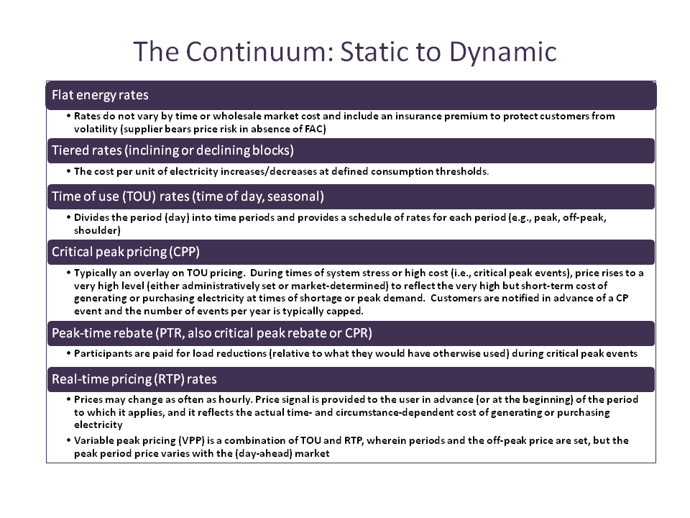
Figure 4-B1 shows a depiction of the range of TVR options and how the potential reward (defined in this chart as the discount from flat rate) compares to the risk (variance in price). The chart shows that real-time pricing (RTP—generally hourly pricing) potentially has the highest reward for customers but also has the highest risk. Time-of-using pricing (TOU) on the other hand has a much lower potential reward but also a much lower risk—with CPP falling between the two. Peak-time-rebates (PT) by contrast, provide a reward (in the form of a rebate) but no real risk (since you only get a rebate when you reduce, but are not penalized if you do nothing).
Figure 4-B1: Risk-Reward Tradeoff in Time-Varying Rates
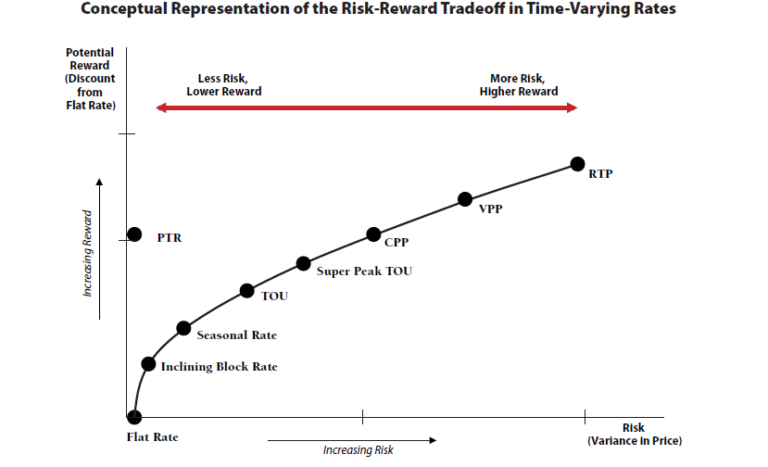

Figure 4-B2, presented by Brattle and by RAP, is a graph of the peak reduction and the peak to off-peak price reduction from 74 TVR pilot programs across the U.S. It illustrates two points. First, higher peak to off-peak price ratios (whether reflected in CPP or PTR) generally elicit higher responses in the form of peak reductions than lower ratios. Second, TVR associated with enabling technology that facilitates load management actions generally increases the peak reduction response. It should be noted that this tables presents analysis of various pilot results which may not be indicative of wide scale deployment. According to a recent Navigant study, adoption rates of TVR in many cases remains low once scaled beyond pilot scope (see 5/22/13 Navigant presentation

Figure 4-B2: Peak Reduction Relationships to Price Ratio & Enabling Technology
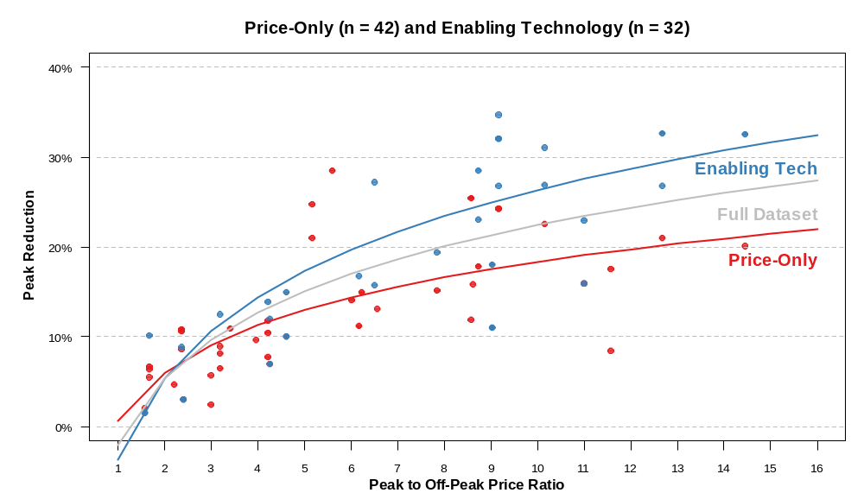

The Massachusetts distribution companies are in various stages of completing their smart grid pilots, which are testing a range of TVR rates as well various metering and other enabling technologies.

Unitil, which already had installed an early AMI metering for all its customers, has completed their pilot. Unitil used a TOU rate with and without enhanced technology and smart thermostats. They found kw reductions with the TOU without enhanced technology of 21% on-peak and 42% during the critical peak period. The savings with the enhanced technology added increased to 35% for on-peak and 70% during the critical peak. The customer bill savings averaged 5% for the simple TOU and 7% with the enhanced technology.
Table 4-B2: Unitil’s Smart Grid Pilot Results
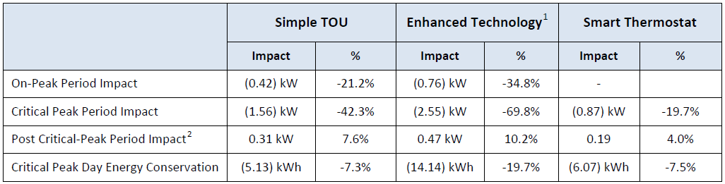
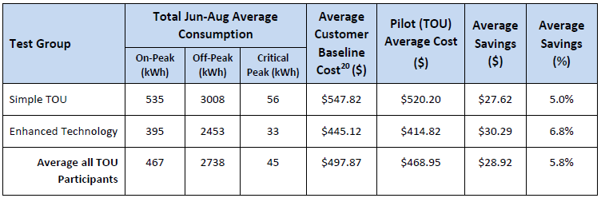
NSTAR is still in the middle of its pilot, which is scheduled to be completed at the end of 2013. NSTAR is using its pre-existing AMR meters enhanced with home area networks for its pilot. As Table 4-B3 describes, NSTAR is testing 3 different TVR approaches (PTR with NSTAR control of a smart thermostat, and TOU with CPP with and without enabling technology), plus a group that will receive enhanced information but stay on their otherwise applicable rates. Figure 4-B3 below shows the interim peak savings during both the summer and winter for all 4 groups of participants. NSTAR presented the results of the first 9 months of its 24-month pilot from an evaluation report completed by Navigant in March 2013. The 3 TVR groups appear to have saved more kw during both the summer and winter peak periods than the enhanced information group—but there doesn’t appear to be a clear winner among the two TOU options and the PTR option in terms of which performed better overall in terms of kw reduction in both the winter and summer seasons.

Figure 4-B4 below provides a summary to show the customer evolution from the number of customers contacted, to installed, and finally the number currently enrolled—including the significant drop-out rate at each stage. The final evaluation and numbers on this pilot should be available in the spring of 2014.

Table 4-B3 NSTAR’s Smart Grid Pilot Customer Test Groups
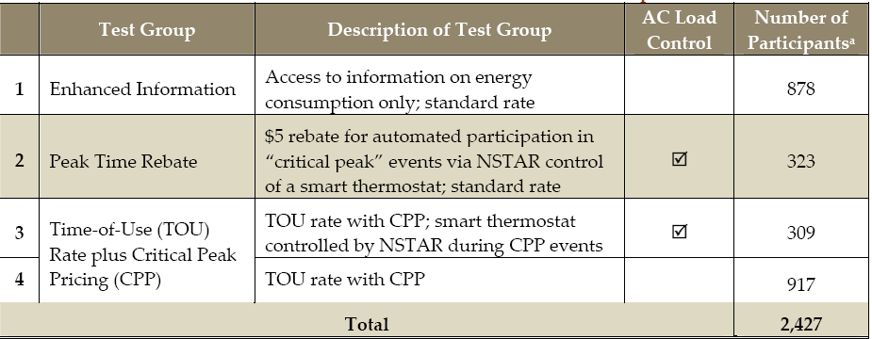

Figure 4-B3 NSTAR’s Average Peak Period Load Reductions (January-September 2012)
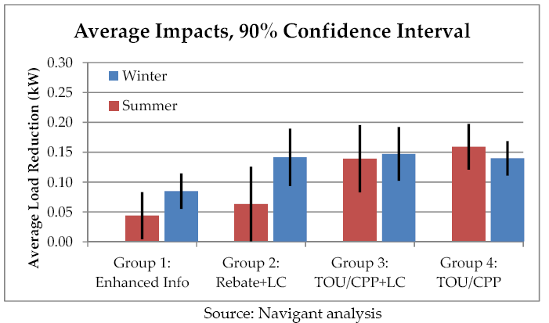

Figure 4-B4
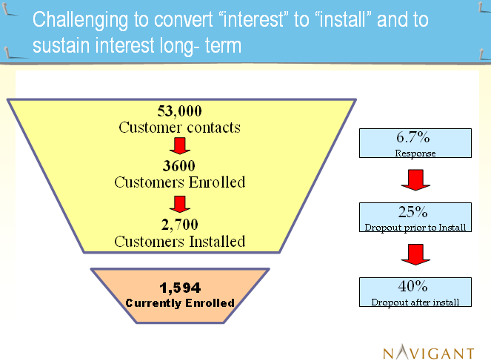
National Grid is just in the process of rolling out its smart grid pilot in Worcester, so no data is available yet except their approved design and initial experience with meter installation. Although NGRID already has AMR meters, it is planning on installing 15,000 AMI meters for the pilot participants. It will offer three different TVR options to its customers: 1) CPP for residential and small C&I; 2) PTR option also for residential and small C&I; and 3) HPP—hourly pricing for largest C&I customers. Unlike the other pilots, National Grid’s pilot is designed as an “opt out” experiment. The utility will enroll customers in the default CPP rate but allow customers to opt out of that rate and either leave the pilot entirely or select a PTR option.

As Figure 4-B5 shows there will also be various combinations of technology options (home display units, smart thermostats and automatic HVAC controls, and load control devices.) Meter completion was scheduled form May 31, 2014 and the pilot TVR pricing starts January 1, 2014.
Figure 4-B5: National Grid’s Smart Grid Pilot 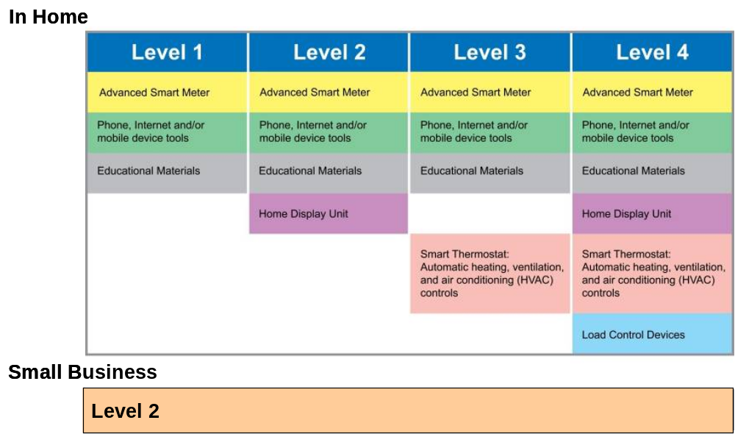

As Figure 4-B5 describes, the Massachusetts Distribution Companies currently have mandatory TOU rates (distribution portion only) for their largest C&I customers. However, for residential and small C&I customers there are legacy optional TOU rates that have been in place for some time but are not marketed or well-subscribed by customers, as outlined in Figure 4-B6: Legacy Massachusetts Distribution Companies TOU Rates.
Figure 4-B6: Legacy Massachusetts Distribution Companies TOU Rates 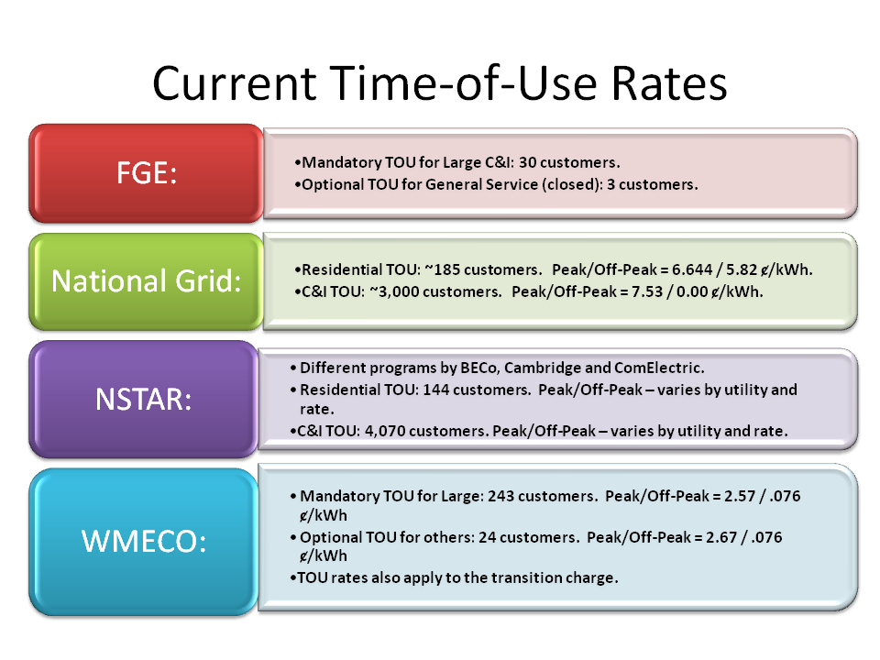
Table 4-B4 is a summary of research done by the Attorney General’s Office on the use of TVR by other restructured states. It found that in each of the states basic service is a flat rate, with a range of TOU and PTR rates that are available on a voluntary opt-in basis.
Table 4-B4: TVR and Metering in Other Restructured States
State/Utility | Type of Metering Prior To AMI (Manual Read, AMR) | Type of Metering (AMI, AMR, or Enhanced AMR) | Basic Service Design | Type of TVR (TOU, TOU/CPP, or PTR) | On Basic/Default Service (supply) Distribution Rates, or Both |  | Opt-In, Opt-Out, or Mandatory
Connecticut |  | Not AMI | Flat Rate | Legacy TOU | Supply Only |  | Opt in
Delaware | Manual Read | AMI | Flat Rate | TOU legacy and PTR | Both |  | Large scale PTR pilot underway; participation is opt in
District of Columbia* | Manual Read | AMI | Flat Rate | TOU legacy | Supply Only |  | Opt in
Illinois | Various | AMI (over 10 years) | Flat Rate | "Real Time" Pricing since 2009; Legacy TOU; PTR in future | Supply Only |  | Opt in
Maine* | Manual Read | AMI - CMP | Flat Rate | TOU | Supply Only |  | Opt in
Maryland* | Manual Read | AMI being installed | Flat Rate | Legacy TOU and PTR | Both |  | Overlay on Basic; participation is opt in
Michigan* | Manual Read | AMI (over 10 years) | Flat Rate | TOU | Supply Only |  | Opt in
New Hampshire |  | Not AMI | Flat Rate | TOU legacy | Distribution Only |  | Opt in
New Jersey |  | Not AMI | Flat Rate | TOU legacy | Both |  | Opt in
New York |  | Various; not AMI | Flat Rate | TOU legacy | Both |  | Opt in
Ohio* | Various | AMI only for Duke and AEP | Flat Rate | TOU legacy; pilot TOU for AMI | Supply Only |  | Opt in
Pennsylvania* | Various | AMI (over 10 years) | Flat Rate | TOU with installed AMI; PTR for one utility | Supply Only |  | Opt In
Rhode Island |  | Not AMI | Flat Rate | None | NA |  | NA
Texas* | Various | AMI | None | Unknown | Unknown |  | Opt in
Notes:
1. This information reflects residential rates only.
2. Several of these Distribution Companies offer optional EV charging TOU rate with or without AMI
3. In these states, licensed suppliers can offer TVR but these rate options are not typical of most offers
* means that one or more Distribution Companies in these states received ARRA funding for up to half of the AMI deployment costs
4. Original spreadsheet also includes description of any TVR or PTR, and whether administered by utility or another (see original on the website at Steering Committee Meeting # 5)
Source: Office of the Attorney General

C) Metering

Metering issues and discussion permeated numerous Steering Committee meetings, as well as both Customer-Facing and Grid-Facing Subcommittee meetings. There were three different pieces of meter-related work overseen primarily by the Customer-Facing Subcommittee to help the Members garner a better understanding of the current metering infrastructure in Massachusetts.
- The Distribution Companies were asked to reply to three sets of data requests to provide information as to their current metering infrastructure and replacement protocols (See: 1) the first set of NU, NGRID, & Unitil Metering Questions HERE 2/26/13; 2)the Compilation of Metering Responses HERE 4/4/13; 3) the second set of utility metering responses and update compilation HERE and; 4) the third set of utility metering responses HERE .
- Three meter-related hardware and software vendors provided the Steering Committee with presentations which focused on options for enhancing metering infrastructure, including types of technology, functionality, and cost (See presentations by Itron, AvCom, and Sentinel Works HERE 1/9/13).
- Lastly, the Customer-Facing Subcommittee and a metering working group that was formed to assist the Subcommittee, spent a substantial amount of time reviewing and analyzing various metering technology options and the manner in which those technologies could support a range of customer-facing and grid-facing capabilities and functions. As part of this review and analysis, the Subcommittee and working group identified the incremental functionality of various technologies. The Subcommittee and working group also worked to develop cost ranges for the various technologies, including the meter cost, installation, and a range of necessary supporting infrastructure. The cost data was initially supplied by ITRON (Itron, HERE 1/9/13 and in subsequent discussions with working group and Subcommittee), and was then adjusted by the Distribution Companies based on their own distribution systems and experience gained from the pilots to date (See Metering Technologies Functions Costs spreadsheet with the various worksheets HERE 4/23).

The Massachusetts Distribution Companies, with the exception of Unitil, all converted their meters from manual-read meters to AMR meters during the 1990’s through the last decade. AMR meters are read from a moving vehicle rather than by a meter reader. Unitil converted its meters to AMI approximately 10 years ago, which allows Unitil to access the metered data remotely without having to drive by or manually read the meter. Table 4-C1 shows the approximate age of the current meters for each Distribution Company, as well as the meters assumed book life and operating life. Based on the information provided by the Distribution Companies, the consultants calculated the last line in the table which shows the average life remaining in the existing meters.

Table 4-C1: Utility Metering Infrastructure—Age, Book Life & Operating Life
 | NSTAR | WMECO | National Grid | FG&E
Approximate average meter age (years) | Energy 10 | Energy 12
Approximate average meter age (years) | Demand 7 | Demand 8-9 | 17.8 | 7.1
Approximate average meter age (years) | TOU 5 | TOU 2
Book life (years) | 24 | 23 | 28.9 | 20
Operating life (years) | 15 - 20 | 15 - 20 | 30 | 20 - 30
Approx. avg. life remaining (years) | 5-15 | 3-18 | 12.2 | 12.9 - 22.9
Figure 4-C1 shows a schedule of when the current meters were installed on each Distribution Company’s system. The figure shows the percent of the total meters that were installed in each year. For example, of all the meters currently installed on the Unitil system, roughly 70 percent were installed in 2006. Roughly 30 percent of National Grid’s current meters were installed in 2002. Each Distribution Company’s current practice is to replace failed or aged meters with “like” meters (e.g., AMR with AMR). According to the distribution companies, the costs and complexities associated with integrating additional end-points and maintaining those interfaces make it impractical and uneconomical to do otherwise (see responses to 3rd set of metering questions HERE).

Figure 4-C1: Schedule of Current Meter Installment: Percent of Total Installed in Year
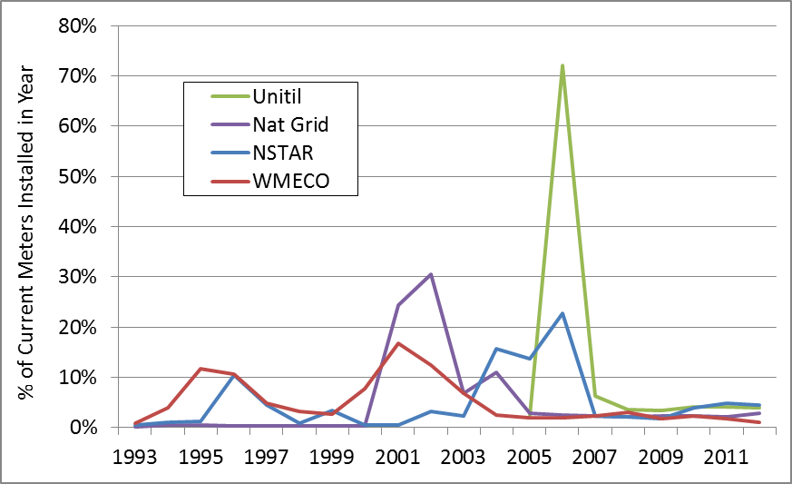
The Customer-Facing Subcommittee, with the help of the working group referenced previously developed a range of metering technology options beginning with AMR, which is currently the most common meter type in Massachusetts, and ending with AMI. Included in this range are several options to enhance basic AMR meters either through home area networks or fixed external area networks. Both of these are options are able to provide information back at the home office without having to gather the data during a drive by meter read. The Subcommittee and working group also learned about a new ITRON metering technology currently under development called a “Bridge AMI Meter” which can continue to act as an AMR meter, and then be switched remotely into AMI mode once a distribution company the utility has all other supporting AMI infrastructure in place. Finally the work group and Subcommittee looked at Unitil’s AMI system—which is a more limited AMI than full AMI, and looked at basic AMR with load control.
Table 4-C2: Metering Technology Options
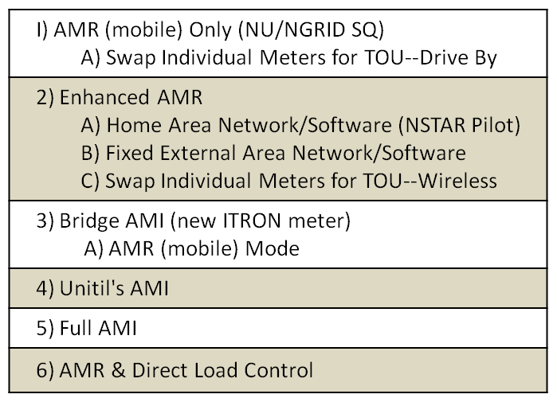

The working group then identified the potential meter-related functionalities of interest with 11 areas of focus shown in Table 4-C3. The working group and, ultimately the Subcommittee, then populated a matrix comparing each of the technologies in a different row with each of the 11 potential functions in a separate column to illustrate the technologies’ capabilities. The detailed matrix,labeled “Functionality” on the website, is located (HERE 4/23). A summary of the incremental customer-facing and grid-facing functionalities for key metering technology options is shown below in Table 4-C4: Incremental Functionality of Metering Options. Table 4-C4 illustrates that, as you progress from AMR through two types of enhanced AMR to AMI, additional functions in certain cases can and in other cases may be supported by the meters and associated infrastructure.

The Subcommittee and working group also worked to provide directional estimates of the costs related to the different metering technology options, including the costs of the meter and installation and a range of supporting infrastructure costs, as well as ongoing O&M costs. The cost ranges were developed with the assistance of Itron and with input from the Distribution Companies based on their experiences with their own infrastructure and pilot programs. (See Table 4-C5: Metering Technologies and Costs below).

The Subcommittee also, as a final exercise, reviewed the meter-related customer-facing and grid-facing functionalities and compared them to various clean energy related activities, such as demand response, distributed generation, direct load control, electric vehicles, etc.. Based on this review, it appears that there are two areas of meter-related functionalities with greatest relevance to clean energy activities: 1) communication to the meter and from the meter to customer devices; and 2) access to interval data on a real time basis. However, for some activities, such as electric vehicle recharging, if a TOU rate is sufficient, access to a TOU register, as opposed to interval data on a real time basis, might suffice to meet identified needs. (See Functionality & Applications worksheet of Metering Technologies Functions Costs spreadsheet HERE 4/23 and accompanying text Metering Functionality & Clean Energy Activity Text HERE 4/23)

It should be noted that, simply because a certain type of meter can support a particular capability or function, does not mean that it is necessarily the only way to enable those functions or that it is cost-effective. For instance, communication for enabling direct load control can be accomplished via other communications protocols without going through the meter.

The Subcommittee and Steering Committee did not endeavor to perform a cost-effectiveness analysis of the different metering technologies and their associated incremental functionality benefits. Rather, the Steering Committee anticipates that such an analysis would need to be performed on a company by company basis at the appropriate time.

Table 4-C3: Meter-Related Functionality

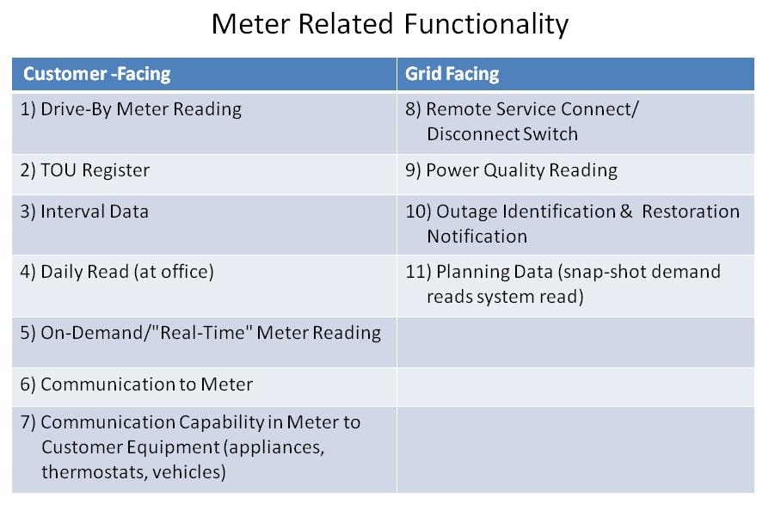

Table 4-C4: Incremental Functionality of Metering Options
Technology Options: | Customer-Facing | Grid-Facing
AMR | Drive-By Meter Reading; One-Way Communication
Enhanced AMR (w/HAN) | AMR PLUS Communication to Customer Equipment and MAY enable Remote Meter Read, TOU Register, Daily & Real-Time Meter Read | MAY enable Outage ID & Restoration Notification
Enhanced AMR (w/Fixed Network) | AMR PLUS Remote Meter Read, TOU Register, Interval Data, Daily Read, and MAY also enable Real Time Data Read, Communication to Customer Equipment | MAY/limited Outage ID & Restoration Notification, and Planning Data
Full AMI | AMR (w/Fixed Network) PLUS Real Time Data Read, Two-Way Communication to Meter, Communication to Customer Equipment, | AMR (w/Fixed Network) PLUS Remote Service Connect/Disconnect Switch, Voltage Reading, Power Quality Reading

Note: “MAY” is due to fact that some of functionality may not be available depending on which meter model is purchased and with some models certain functionality
is optional and requires additional fees.
Table 4-C5: Meter Technologies and Costs
 | Meter (equipment) Costs | Installation Costs | Home Area Network Enablement | Software & Network Infrastructure | Other Smart Grid Infrastructure (OMS, DMS, GIS) | Total Cost (1) | DLC at Device (for interested customers) | Annual O&M (as percent of capital cost)
I) AMR Only (NU/NGRID SQ) | $30-50 | $20-40 | NA | $2 | NA | $52-92 | $100-150 | 10-30%
A) Swap Individual Meters for TOU--Drive By | $120 | $20-40 | NA | $2 | NA | $142-162 | $100-150 | 10-30%
2) Enhanced AMR
A) Home Area Network/Software | $30-50 | $100-200 | $125-175 | $2 | NA | $257-427 | $100-150 | 10-30%
B) Fixed Area Network/Software | $30-50 | $20-40 | NA | $15-30 | NA | $65-120 | $100-150 | 10-30%
C) Swap Individual Meters for TOU—Wireless | $300-600  (C&I only) | $20-40 | NA | $2 | NA | NA | $100-150 | 10-30%
3) Bridge AMI (new ITRON meter)
A) AMR (mobile) Mode | $120 | $20-40 | $125-175 | $ 2 | NA | $247-437 | $100-150 | 10-30%
B) AMI (network) Mode | $120 | $20-40 | $125-175 | $50-125 | $50-190 | $365-680 | $100-150 | 10-30%
4) AMI (Unitil SQ) | $70-150 | $20-40 | $75-150 | $50-125 | $50-190 | $265-655 | $100-150 | 10-30%
5) Full AMI (2) | $80-150 | $20-40 | $125-175 | $50-125 | $50-190 | $325-680 | $100-150 | 10-30%
6) AMR & Direct Load Control |  |  |  | $5-10 |  |  | $100-150 | 10-30%

Notes:
(1) The Total Costs are simply a total of the min-max individual costs. Actual upgrade costs will vary based on functionality deployed.
(2) Ranges on AMI in part related to different functionality
(3) Cost estimates based on combination of ITRON supplied cost, and MA utility experience
(4) In 3B if Bridge Meter already installed in "mobile" mode, no incremental equipment or labor cost to switch to AMI (network) mode
(5) Row 2A is based on NSTAR pilot costs, scale deployment could be different
(6) Software/Network Infrastructure cost relatively fixed, and likely lower cost/meter for large systems than small
(7) Other Smart Grid Infrastructure can vary significantly depending on pre-existing infrastructure and what other options to pursue
and based on ITRON's analysis of other jurisdictions
(8) For DLC end costs/installation same, but communications cost vary significantly--i.e., likely less expensive for AMI

WMECO has approval for a settlement agreement with the AG, DOER, and the Low Income Weatherization and Fuel Assistance Program Network and the Massachusetts Energy Directors Association to file with the Department a modified smart grid proposal when two conditions are met: 1) WMECO’s new MDM is operational; and 2) the other Massachusetts electric Distribution Companies' Section 85 pilots have been completed, and the resulting statewide evaluation process has been concluded.
Unitil’s evaluation report was filed in January 2012 but there has not been any public review of the report or formal consideration of its results, including its statistical validity, by the DPU.
According to NGRID of the first 5,000 meters installed, 297 or 6% of customers opted to not have meters installed.

